**최종 관통 프로젝트 설계서**

12기 광주 5반 3팀

김자연, 정현수

1. 요구사항 정의서

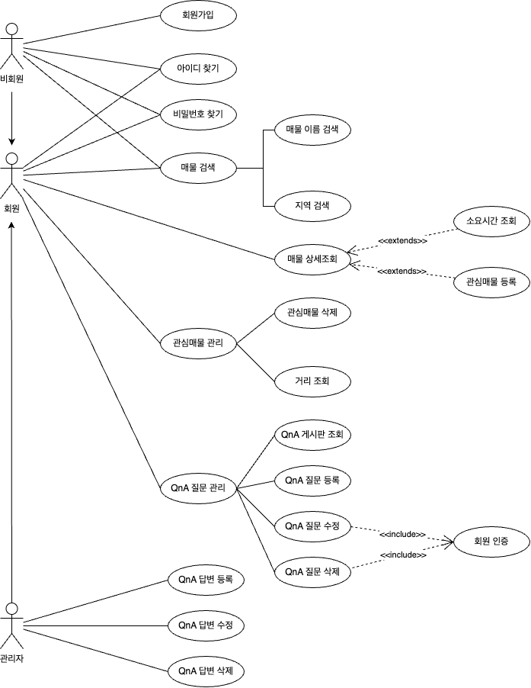

2. 테이블 구조도

3. 클래스 다이어그램

